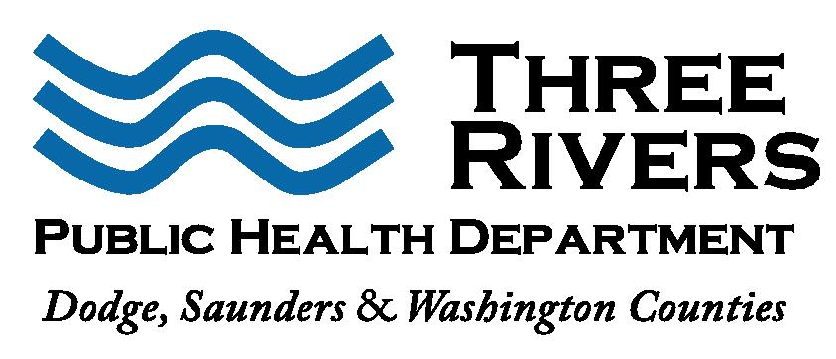
FOR IMMEDIATE RELEASE: 6/19/2020
Terra Uhing, MS
Executive Director
(402) 704-2254
terra@3rphd.org

Update on Three Rivers Public Health Department COVID-19 Cases

Three Rivers Public Health Department (3RPHD) reports total lab-confirmed COVID-19 cases within the district as follows:
Dodge County: 651 cases
Saunders County: 60 cases
Washington County: 43 cases
Total 3RPHD Case Count: 754 cases

As of Friday morning, local hospitals reported 344 medical beds were available and 104 patients were hospitalized with COVID-19. Of the 367 ventilators available to area hospitals, 116 were in use, including 28 for confirmed COVID-19 patients.

Sadly, we received word of a COVID-19 related death a Dodge County man in his 40s. This brings our total to 9 deaths in Dodge County, 2 deaths in Saunders and 1 death in Washington County for a total of 12 deaths in the 3RPHD health district. Assume that COVID-19 is present in all our communities and conduct yourself accordingly. Please be aware of the COVID-19 symptoms, which may include a fever, cough, sore throat, severe fatigue, loss of taste and smell or difficulty breathing. In most cases, a person will have more than one of these symptoms. Anyone who has COVID-19 symptoms or develops symptoms should contact their health care provider and tell them how you are feeling and any possible history of exposure. Please call ahead before you go to the doctor’s office or an emergency room.
As some restrictions due to COVID -19 are relaxed, 3RPHD asks you to remember the basics. Maintain social distancing, wear a cloth mask in public, and wash your hands often for 20 seconds with soap and water. It is a time to take care of yourself and remember to reach out and help others when you can.
Test Nebraska is here and 3RPHD is encouraging more individuals to seek testing. Help us identify cases, predict and give employers and the public reassurance that those who have COVID-19 know it and are staying home. Visit https://www.testnebraska.com/en to take the test and see the schedule. There is no cost for this test through Test Nebraska.
Why is it important to consider testing?
- The sooner we can identify COVID-19 cases, the sooner we can get back to our normal way of life.
- In addition to social distancing, widespread testing is a proven, effective way to combat the spread of COVID-19.
- Testing gives us crucial data that we need to track the spread of the virus, contain it, and to help find a cure and save lives.
For more information about COVID-19 please visit www.threeriverspublichealth.org, http://dhhs.ne.gov/coronavirus.
###

