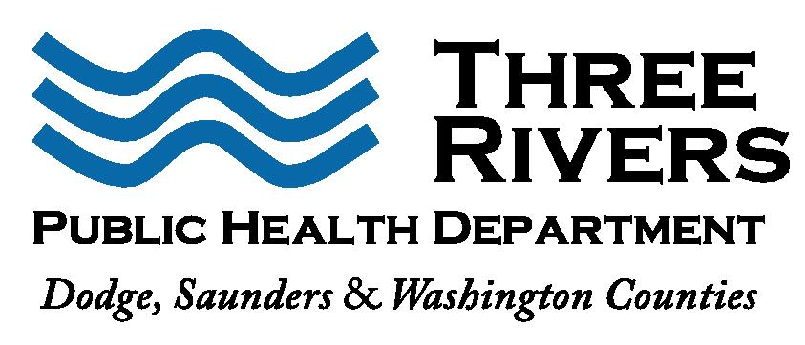FOR IMMEDIATE RELEASE: 5/15/2020

Terra Uhing, MS

Executive Director

(402) 704-2254

[terra@3rphd.org](mailto:celeste@3rphd.org)

**Three Rivers Public Health Department confirms additional cases of COVID-19 from Mass Testing on May 10th**

Three Rivers Public Health Department (3RPHD) worked with the Nebraska Department of Health and Human Services and Nebraska’s National Guard to conduct a mass testing event on Sunday, May 10, 2020. The event was held at Christensen Field in Fremont. 3RPHD worked in collaboration with local partners (hospitals, food production facilities, and emergency management, etc.) to identify potential candidates for testing. Additionally, close contacts of previously confirmed cases were also invited for testing. In total, 238 individuals were tested.

From the testing event, 30 new confirmed cases were identified (there will be a press release later in the day to give the most up to date County numbers):

* 6 pediatric cases in Dodge County
* 20 adults in Dodge County
* 4 adults outside of the Three Rivers Public Health Jurisdiction

Please be aware of the COVID-19 symptoms, which may include a fever, cough, sore throat, severe fatigue, loss of taste and smell or difficulty breathing. In most cases, a person will have more than one of these symptoms. Anyone who has COVID-19 symptoms or develops symptoms should contact their health care provider and tell them how you are feeling and any possible history of exposure. Please call ahead before you go to the doctor’s office or an emergency room.

For more information about COVID-19 please visit [www.threeriverspublichealth.org](http://www.threeriverspublichealth.org), <http://dhhs.ne.gov/coronavirus> or call United Way’s 2-1-1 Resource Hotline.

###